Network Optimization of Supply Chain Operation for Fast Moving Consumer Goods

Abstract
Supply chain illustrates on fulfillment of consumer demand functioning smooth process for more accurate and reliable real time application especially in production line effectiveness. Production denotes on supplying commodities on time for consumer attraction. An ultimate planning can enclose the situation of consumer and manufacturer obsession. The appropriate Supply Chain Network should be introduced following production quantity and storage capacity. Discrete Event System usually accommodates to figure out 9061 networks which drive a best simulation output analyzing the condition of production process, plant location, factory capacity, storage capacity and demand fluctuation. The Inverse transform method terminates simulated time of an event compilation applying exponential inter-arrival conditions along with (max, +) algebra identifying 1148 networks eligible for supply chain process. A term Mixed Integer Linear Programming also used to optimize the situation for developing more optimum and reliable condition to evaluate Supply Chain operation variables to seek out 141 networks for 26 products. Machine Learning remembers as blessing for Supply Chain to predict the situation of applying newest Supply Chain Network for a product. A mathematically simulate networks like Gaussian probabilistic distribution scoring Bayesian Information criteria can create more positive impact into the application procedure of Supply Chain strategies. The cross validation evaluates to identify the number of clusters required as selected 15. Production line of Fast-Moving Consumer Goods needs to be analyzed for meet the consumer demand appropriately. Fast-Moving Consumer Goods products dilute the demand situation based on trade flow situation, natural issues, manufacturing and storage capacity and so on. This research discusses on the optimization of Fast-Moving Consumer Goods Supply Chain Network under analyzing real time situation.

Introduction

1.1 Background
In this global situation, Supply Chain depicts as vulnerable topic for maintaining Sustainable Development Goals in producing daily life commodities for ensuring demand of consumers. Every sector interconnect to create a chain for completing complex situation. Supply Chain dynamically enter into the complexity of application for adapting the demand situation. Sourcing of raw materials is fundamental point for Supply Chain Management, because of multiple stakeholders, negotiators and their relations. Supplier selection is a crucial element of Supply Chain which controls the product conditions and diversification. Even, there has artificially created a geopolitical situation, late responsiveness, resilience for trust issues and more relevant. For this, Supply Chain strategies must have the multiple tiers selection criteria which obviously pertains a complexity condition. Manufacturing can maintain the Supply Chain cost effectiveness and quality of product. Production line should be more sensitive issues to making an institution profitable. The right decision for managing the Supply Chain Network needs to optimum realization for application in running Supply Chain Operation. Optimization is a technique to reach the decision taken to analyze the situation experiences. As the production condition become more critical with time being, it is needed to solving and proper process design accumulation for consumer demand requirements. Country based situation can create a highly destructive compilation not to take a sustainable and reliable decision for specific area according to its environmental situation, psychological conditions of people, transportation situation, risk capacity and more on multi-dynamic possibilities. However, most important thing is the consumer interest which dynamically control the demand of a product according to their attraction rate empathy. So, the consumer psychology is the most crucial thing to discover from their daily life and history of taste. For this, all the situation needs to be optimized and simulated with futuristic knowledge about the application of Supply Chain Network. However, supply chain is the vital management role for a company to build a sustainable, environmental safety, profitable, socially responsible and strategical business development.

1.2 Supply Chain
The integration of planning, coordination and implementation of dynamic networking systems of businesses with complex, strategic and evaluative activities involvement of products or services executed in raw material sourcing, transporting, storing, and delivering encompasses supply chain management. The synchronization of information, multi-echelon networks, financial statements, flow of materials and manufacturing facilities incorporate the operation of supply chain process. The collaboration with entities, flow operation, design of strategic network and cost management of supply chain systems require analysis to evaluate the absolute execution on real systems. At that point, the entities such as suppliers, manufacturers, distribution centers, retailers and customers encircle interdependency between them. The essential embracement of supply chain indicates to connect structures of processes. The scopes delivering network configuration, facility allocation, tactical analysis generates core illustration of processes. Effective supply chain management terminates using real-time decision-making system, visibility enhancement, transparency of execution integrating artificial intelligence, Internet of things, digital technologies and advanced analytical tools. However, demand uncertainty and disruptions of supply chain processes established resilience with developing complexities in chain networking systems.

1.3 Fast Moving Consumer Goods
Fast-Moving Consumer Goods products are the most vital for the Supply Chain Network complexity covered an area to replenished customer satisfaction in the manner of controlled strategies. Daily commodities need to quick sold and with low-cost facilities. For this reason, the manufacturers need to take collaborative relationship with the suppliers and distributer. As the varieties of products in Fast-Moving Consumer Goods sector have to be extended multiple entities in Supply Chain Network, the networks need to be proper operation by facing no deamination. But the problem is to become a complexity arise into the smoothness application of the strategies. The strategies are controlled by trade flow condition, duration time, sustainability, impact on society, environmental issues, customer interest, investment flexibility and more relevant to Supply Chain Network design process. Therefore, safe and feasible Supply Chain Networks have to be synthesize using the technologies of the Fifth industrial world.

1.4 Operation Research
The management science under discussion on advanced mathematical methods to execution of analytical approach to develop facilities on data-driven solutions solving problematic situation and taking decisions entitle operation research. Real world organized with complexities and ungovernable conditions which indispensable in imaginary compliances for estimating real scenarios. At that point, interdisciplinary fields of scientific and mathematical knowledge assist to formulate observable situation and analyzed to forage optimum condition with feasibility. Core components comprise in operation research of data collection, data synthesize, problem identification, model development, look out solution, optimization solution suggestion with validation and performance evaluation through Linear programming, Mixed Integer Linear Programming, Queueing Theory, Game Theory, Simulation and Markov processes. Supply chain operation countenances to scheduling, transportation routes, inventory levels, resource collection and storing, facility location along with organizational alignment reinforce to those operation research techniques for optimization and guidance.

1.5 Machine Learning
Artificial intelligence demonstrates with vast number of systems to identify pattern and decision making through data-driven predictions of every task amplification machine learning, a branch, progressing towards training mathematical model. Human intervention in taking decisions idealize as aged process required fast decision-making systems using computerized mathematical and analytical methods. Machine learning begins to influence in patterns and relationship of historical data and decision-making models by accessing data collection, feature extraction, training mathematical models, model evaluation and optimization with deploying as working procedure. Supply Chain operation promulgates with such situations suppling, manufacturing, distributing, storing and consumer attracting to require tracking and identifying on times through digital technologies based on artificial intelligence with smart role of machine learning. The evolution of machine learning by time as known as supervised, unsupervised and reinforcement learning which rectified on leveling historical data, presenting hidden data structures and agent-based trail-and-error models respectively. However, the complicated and sensible decisions and futuristic demonstrations become inconvincible by machine learning.
Being increased various indicators and uncertainties, Supply Chain Networks encounter with more complexities which need to eradicate by establishing sustainability into the Supply Chain Network Design using solution techniques. [1] Supply Chain Disruption incorporates for the COVID-19 epidemic causes economic instability and risk in Steel Industries of Bangladesh mitigating the loss of stakeholder by taking strategies applying Best Worst Method to enhance resilience and proper policy development.[2] For greening the marine sector, the ships and ports operate through controlling greenhouse gases by creating appropriate Supply Chain Networks optimizing the regulations and guidance parameters using Mixed Integer Linear Programing to minimize the operating and depreciation cost. [3] Internal or external global networks examine by analyzing supply chain integration on the basis of flow-based taxonomy, market scope, tailored product, local inputs, production scope, low-cost advantage and relevant parameters on supply chain management. [4] R&D and manufacturing have exempted integrating material to product process, requirements of materials, preliminary laboratory investigations, qualification and sourcing from vendors, understanding and optimizations of process variations, business usability, scale up to actual parts etc. related data assisting to analyze the arrival problems. [5] For establishing a global Supply Chain for Multi-National company, the company size has to be the ability to adoption with the Supply Chain integration of mechanism resources and power with geographical situation analysis and the economic condition of the adopted country and all thing evaluated by using MANOVA. [6] For mitigation of socio-economic degradation for natural disaster, Supply Chain Networks of firms need to be enabled by using Agent Based System for analyzing the complexities of networks and relationships for covering up direct and indirect losses. [7] Disruption of Supply Chain Network can be created by geographical imbalance focusing to implement the improved strategies resilience Supply Chain performance using mathematical models evaluating the event condition parameters. [8] Supply Chain Quality Integration depends on supplier and customer quality integration which operate the networks with better performance and using Smart PLS for analyzing absorptive capacity from the theoretical extensions. [9] Logistic replanning for the shipments distribution creating impact on transport modes, cost management, efficient network algorithm and more analyzed by path-based multi-commodity network flows on account of time-space network.[10] Supply Chain Management System is analyzed using DES (max, +) algebra equations to describe the study by obtaining Timed Colored Petri Nets system behavior according to consider the entities evaluation of product situation. [11] Simulation based optimization remains to impact on decision making to design Supply Chain Network evaluating the sceneries of Supply Chain operation executing DES and MILP for optimum possibilities for implementation on the controlling production level respecting demand. [12] Optimization of trans-shipment in a port contains a reliable terminal operation on handling the vessels and containers using the meta-heuristic for extracting new theories, ML and queuing theory to solve the yard-allocation problems. [13] Supply Chain Inventory level denotes on the disruption of Supply Chain, demand equilibrium policy, cost inequalities, planning influence and more needed to optimize by MILP by conducting through inventory policy parameters. [14] Returning products in between customer to customer creates problem to function the Supply Chain Network for the impact of economic and environmental issues and disorder on logistics and warehouse arrangement by analyzing Simulation Optimization and Reinforcement Learning for finding out the result. [15] In Supply Chain Management field, the Artificial Intelligence adds a new technique to make the networks decision optimizing potentiality of data driven systems to reach the ultimate goals of logistics, marketing, Supply Chain and production planning.[16] In Logistics and Supply Chain Management, ML is the upcoming technology to discover the new optimization Supply Chain Network in modern world featuring the variables taken from the transportation indicators, logistics sceneries, distribution condition, customer behaviors and the situation of application of Supply Chain strategies.[17] Effective Supply Chain Network is the main thing for a successful business organization, so the decision making of Supply Chain processes analyzing the criterions of the strategies to conduct the benefits and challenges solving by Deep Learning and Machine Learning.[18] The era of Industry 4.0 becomes more complex in all fields to fastest way to analyze a system like Supply Chain Network using Deep Learning and Machine Learning for making decision and realize the future condition using the historical data by handling a vast amount of mathematical and statistical models.[19] A real-world Supply Chain Networks implementation of Fast-Moving Consumer Goods companies based on situation of demand sceneries analyzing by Graph Neural Networks to demonstrate a prominent firm for production-oriented Supply Chain planning.[20] Clustering in unsupervised learning is an essential application of data extracting and pattern identification using Gaussian Mixture Model of scoring through Bayesian information criteria to eliminate traditional process of model development.[21]
Operational Management and Supply Chain Management has been existed from the very beginning of civilization even before the establishment of scientific theories and explanation. Initially, operation was taken as short time and tactical planning with management. But it became converting to strategic planning and competitive advantages. At that moment, the world was being introduced with the mathematical models which inaugurated with the operation research and management sciences. The mathematical models needed to become more complex to solve the daily world strategical problems. Then, the world was encountered with new topic named Supply Chain Management which created a relation among purchasing, logistics, operations, transportation, and marketing. For developing a sustainable strategy, the sustainable development goals were announced. As the complexities expanded and business interactions increased, the research on supply chain management and operation management become evolving.

Research Methodology

3.1 Introduction
This research conducts for optimizing networks for developing an optimum and cost-effective production process. Supply Chain optimization needs to extract the features from happening situation in the application of Supply Chain Network. Those features help to simulate the networks using mathematical models according to timeseries. The optimum situation helps to know about more feasibility of Supply Chain Network. The upcoming condition discussion beware to applying the Supply Chain Network in real world.

3.2 Feature Extraction
Supply Chain Network system is a core operational approach for a running continuity of a Fast-Moving Consumer Goods based company. Multiple products can create diversified networks between production plants and storage location. Warehouses are mostly allocated flexible position of the production plants. Production is the most vital feature for Supply Chain Network system which persuade through fulfillment of consumer interest, transportation capacity, remainder of sales and peak time urgency. Consumer order is completed according to purchase order, clearance through the accounts department and approval of customer end quantity. Shipment of goods is the basic process for recognizable revenue consistency and right quantity for right time to create a reliable distribution relationship. Potential destination alignment needs to establish for shifting products for appropriate location such as some products to the consumer directly from manufacturing unit and some are to the warehousing for storage. Features on Supply chain networks of Fast-Moving Consumer Goods companies depend on multiple parameters in below which return to attributes calculating appropriate decisions.
- Plant Location: It sets down manufacturing plant with producing multiple types of goods. The reason generates different types of products produced in each particular plant. For that, plants can manufacture similar commodities within selected times.
- Storage Location: Manufacturing commodities necessitate storing several locations with multifarious items. Multitudinous goods specify in each storing compartment. As a result, there develops networks in storing products.
- Production Process dependency: Each plant delivers dissimilar products in a particular time, indetermined multiple items of raw materials and processes established several networks.
- Production Amount: Number of quantities in units of commodities proffer to be fabricated within a single day.
- Deliver to Distributer Amount: Number of quantities in units of commodities proffer to be distributed within a single day.
- Factory Issue Amount: Number of quantities in units of commodities entail to movement in between plant site within a single day.
- Sales Order Amount: Number of quantities in units of commodities entail to get order from consumer within a single day.
Developing Supply Chain Network, distinct products need to be targeted, so pointing product is main appropriate feature. Again, production plant position and storage location are also basic features for Supply Chain Network design. Analyzing Supply Chain Network, production quantity, sales order number, delivery quantity and production destination are main features to create the DES for better segmentation to predict actual Supply Chain Network by ML and focused to develop recognizable Supply Chain Network.

3.3 Segmentation Events compared to Timeseries and Networking system
The data contains a timeseries between January 1, 2023 to August 9, 2023 which almost 7 months on board. So, there has an effect of seasonality issues. For this reason, the distribution of timeseries is badly essential to develop. For this distribution, it is needed to execute the DES for making actual and potential network allocation. The maximum possible values can be terminated for the execution of DES. Besides, MILP evaluates to direct the prominent network after analysis the features. MILP methods are created by multiple networks and execute multiple values. ML needs a structured data values for executing the algorithms in a sequential process. Even if, the algorithms are executed by following target network pathway.

3.3.1 Data Segmentation for DES
DES pertains to simulate a system using mathematical models evolving over the continuity of distinct event occurrence. The events continuously change by time according to following every aspect ratio stimulation to perform betterment of Supply Chain Network. Basically, this research contains product identification with production line and storage pathways. So, the networks are being simulates through production, sales orders, delivery distribution and factory effects. The data must have the values of plant location, warehouse location, product identification code which develop functions for DES and the function exempted by the units and weights of stimulation parameters according to timeseries.

3.3.2 Data Segmentation for MILP
MILP optimizes decision making operation of a running network systems to the momentum of parameters following changing time. A branch of parameters is needed to develop MILP constraints. This research has production, sales orders, delivery distribution and factory effects parameters which effects Supply Chain Network system constraints and objective function. The parameters are in units and weights which determines Supply Chain Network of our targeted network.

3.3.3 Data Segmentation for ML
ML remains to predict the direction of strategies taking the execution of Supply Chain Network using plant location and storage position by forecasting upcoming conditions on the basis of Supply Chain related variables. This research pertains quantity of production, sale, delivery and factory handling as variables of ML models. The variables predict the future conditions of the networking systems and develop more efficient Supply Chain Network pathways.

3.4 Programming Process and Technologies for Segmentation
Supply Chain networks develop through the Supply Chain features named product identification, plant location and storage location. This research follows to execute the DES, MILP, ML using python, a high-level programming language. Python reads the data from the system and using modules which are developed by the python developer. The program basically runs on the VS code, a Microsoft code editor compact with terminal. The modules are used named Pandas for handling the data, NumPy for mathematical operations, SciPy for DES and MILP, Sklearn for ML and matplotlib with seaborn for data analysis. Python has some basic mathematical function to operate the system condition. The modules such as SciPy, SKlearn and mathematical operation need a structural data which can be featured through Pandas and Numpy modules. The Supply Chain features are operated through the modules creating a randomness in values for pertaining train and test data. DES, MILP and ML need to be tested by using statistical random segmentation of whole dataset. The dataset also checks for having no missing values, specific data types.

3.5 DES Model Extraction
DES works to concern with mathematical models which are established on some parameters. This research has the parameters which extracts to follow the Supply Chain Network feature extraction. In Supply Chain Network, the nodes are given specific identities like plant as P, storage as S, product identification as Pd. The nodes are connected to analyze the constraints building on the basis of units and weights of production as u_{p} and w_{p}, sales orders as u_{so} and w_{so}, delivery distribution as u_{dd} and w_{dd} and factory effects as u_{fe} and w_{fe}. The constraints are synthesized by the optimal values execution and checking according to timeseries condition of Supply Chain Network. The variables must be a value remaining sales order and production. Besides, P, S, Pd, u_{p}, u_{so,} u_{dd, and} u_{fe} need to be analyzed for the event simulation. This research is used two selection events to simulate the Supply Chain Process. Presenting the actual material sourcing for participating of selection supply chain networks requires below processes.

3.5.1 Selection of Random Variables
Real world system may functionate through humanoid interaction with the help of technology, a large amount of dependency on mathematics to identify anything most intelligently. Most of the cases logical interpretation accords to select situations. According to Monte Carlo simulation, there have random variables accepted from presenting human behavior and real time possibilities. The random variable is accepted in between 0 to 1, as expression on R. As a result, some logical situation in supply chain and production as priority basis may develop below:

- Highest sales order than total products in hand
  - Daily production can meet the sales order; most prioritize than others: R = 0.9
  - Daily production cannot meet the sales order.
    - Less than 100 units of product may not in hand; less partially prioritize:
R = 0.5
    - More than 100 units of product may not in hand: less prioritize: R = 0.2
- Lower Sales order than total products in hand; Partially prioritize: R = 0.7
In contrast, random variable may represent any situation that create essentiality of supply chain networks which are great responsible in profit increment and cost minimization. Such as, R = 0.9 may point out on every single day remaining in working processes of production equipment. R = 0.7 recalls meeting sales order by taking large amount of inventory, may create cost increment. R = 0.5 may create few amounts of shortage inventory, but R = 0.2 large amount of shortage. Random variable terminates priority basis production of commodities.

3.5.2 Inverse Transform Method for Exponential Inter-arrival Times
Supply chain and production systems transmute events generating on simulation modeling evaluating operational realities for looking out actual networks implementing on real world and future decisions. Discrete Event Simulation requires mathematical presentation, terminated to use Inverse Transform Method for Exponential Inter-arrival times representing attribute simulation of time. Selected parameters individually recall simulated time attributes which represents virtual completing scenarios.
Inverse transform method represents simulated time in particular period of each parameter used as supply chain and production identifier. For this, exponential inter-arrival times are being essential for executing the simulated time. The parameters such as sales order and production in unit operate time for analyzing networks situation evaluation. Basically, sales order and production unit rate of a day remain with random variable selected by priority basis of production process and sales order compilation.
The cumulative distribution function executes the time function:
$F\left(t\right)= e^{-λt}, t≥0$ (3.1)
λ = Rate of events in seconds as example production unit per second
t = simulated time
Placing F(t) = R for evaluating time for more prioritize and simplifying (1 - R)
$t= -\frac{1}{λ}\ln\left(R\right), R ϵ (0, 1)$ (3.2)

3.5.3 Using (max, +) algebra simulation
A mathematical framework for analytical description of Discrete Event Systems develop to select supply chain network by governing resource sharing, synchronization, parallelism and competitive nature. Mainly, two special functions of arithmetic operations replace (max, +) algebra for identification evaluation. Comparison and competition between event timing succor to sovereign the upcoming networks using previously occurring situations. For this, simulation of that representation wipes out the non-functional and ineffective networks.
The (Max, +) algebra identifies the simulated time required for not selecting maximum time consumer networks. A mathematical framework designing linear analytic description of Discrete Event System to exempt supply chain and logistic networking system for synchronization, competition, resource sharing along with parallelism to pick out appropriate networks for simulation. The algebra replaces for two arithmetic operations to identification of production and supply chain process.
- Addition: In (max, +) algebra, it represents maximum function as example a⊕b = max(a, b).
- Multifaction: In (max, +) algebra, it represents addition function as example a⊗b = a+b.
Here, a, b are two entities of time for comparison.
The state of production line and network processes accompany on several facilities. All of those facilities only two of them constitute A_{i} and B_{i} as processing times and facility dependencies of events in dynamic behavior of a network.
$X_{i}<j_{i}>\left(k\right)= A_{i} ⊗ X_{i}<j_{i}>\left(k-1\right) ⊕ B_{i}⊗U_{i}<j_{i}>\left(k\right)$ (3.3)
Here, $X_{i}<j_{i}>\left(k\right)$ is the state vector time of k-th event, $U_{i}<j_{i}>\left(k\right)$ is the input vector

3.6 MILP Model Extraction
MILP executes through mathematical model for network flow optimization on the basis of the parameters. The parameters develop a branch of constraints. The constraints generate the values of decision variables using with appropriate co-efficient and differentiate with the objective functions for final outcome validity. The objective functions terminate a maximize output, if the variables are found exact output. In Supply Chain Network, the weights and units of production, sales order, delivery and factory issues are developed decision variables and the plant, storage, product identification develop constraints followed as network nodes with co-efficient of units or weights. After satisfying the objective functions, the networks are applicable to execute and allowed the case study to take better decision.
The mixed integer linear programming operates cost variables of parameters to execute operation like production process, inventory, internal transmission and sales order compilation. The maximization of profit by objective function evaluates the decision variables applying constraints.
Decision Variable:
x_{so} = sales product price per unit
x_{p} = production cost per unit
x_{d} = delivery cost per unit
x_{fs} = factory issue cost per unit
Constraints:
$x_{p}-mx_{so}≥0$ (3.4)
$x_{d}-nx_{so}≥0$ (3.5)
$x_{fs}-px_{so}≥0$ (3.6)
$x_{p}a_{p}+x_{d}a_{d}+x_{fs}a_{fs}-a_{so}x_{so}≥0$ (3.7)
$x_{p }+ x_{d}+ x_{fs}-lx_{so}=0$ (3.8)
$x_{p}, x_{d}, x_{fs}, x_{so} ≥0$ (3.9)

Here, m, n, p and l are respectively percentage of production cost, delivery cost, factory issue cost and operational cost with respect to total cost.
Again, a_{p}, a_{d}, a_{fs}, a_{so} are respectively production, delivery, factory issue and sales order amount in unit of a day.
Objective function:
Profit Maximization = $x_{so}-(x_{p}+ x_{d}+ x_{fs})$ (3.10)

3.6.1 Co-efficient of constraints
Supply chain and production operation run through a business strategy depended on types of products to develop cost structures. As cost structure in operation is a fundamental strategy to secure the financial stability, the rate of cost distribution must be functionated in feasible and sustainable.
Typically, the hierarchy of costs form ranking of highest to lowest cost per unit where are presented such as below.
- Production cost: Highest cost in operation for raw materials, production processing and employee handling. The percentage of production cost is 65% of total sales as selected for fast moving consumer goods production.
- Delivery cost: Medium cost in operation for transportation and distribution. The percentage of delivery cost is 25% of total sales.
- Factory Issue cost: Lower cost in operation for internal factory conditions handling. The percentage of factory issue cost is 10% of total sales.
- Operating cost: Fast moving consumer goods company may select the operation process and take decision of financial conditions to take stability of company. So, it is taken three operating costs such as 60% and 70% of total sales in one financial year.
Now, calculating cost ratio and percentage
cost ratio of delivery and production cost, k = $\frac{Delivery Cost}{Production Cost}$ (3.11)
cost ratio of factory issue and production cost, H = $\frac{Factory issue Cost}{Production Cost}$ (3.12)
Suppose, Operation Cost = $l$
Percentage of production cost, m = $\frac{l}{1+k+H}$ (3.13)
Percentage of delivery cost, n = m*k (3.14)
Percentage of factory issue, p = m*H (3.15)

3.7 ML Model Extraction
ML in Supply Chain Network basically terminates the future of the movement of Supply Chain strategies application based on the parameter’s dynamics. It can predict the possibilities of appropriate Supply Chain Network building mathematical and statistical formulas. The formulas followed the features of Supply Chain Network models with Supply Chain responsible parameters which extract from the historical dataset. The formulas direct outputs as prediction of upcoming timeseries. For networking system, the models are generated named Decision Tree, XGBoost, Random Frost, Linear Regression, Nearest Neighbors for units or weights prediction and Gaussian Mixture, k-means, hierarchical clustering, DBSCAN, HDBSCAN for network segmentation. The models train by the historical dataset following the features with appropriate data types. There has a test dataset to optimize the models.
As the dataset has no levels and create patterns, unsupervised learning is referred as tracking and detection of region from which points become spread. Supply Chain basically focus on demand of commodities, execution of actual amount of production, delivery process and time, inventory condition and quantity and raw materials accessibility. In the context of production, previous data can assist to develop a pattern to follow supply chain network processes. In addition, the segmentation of operation criteria such as production quantity, sales order, distribution handling and factory application estimates probabilistic distribution of each observation as exact one cluster. As a result, Gaussian Mixture model of unsupervised learning directs to predict cluster and observation situation.
Suppose, a dataset $X=\{x_{1}, x_{2},x_{3},,,,,, x_{n}\}$ consists of $x_{i} ∈ R^{d}$ each observation presenting probability density function of entire mixture.
$p\left(x\right)= \sum_{k=1}^{k}{π_{k}N(x|μ_{k}, σ_{k}^{2})}$ (3.16)
For a d-dimensional variable the Gaussian probability density function
$N\left(x | μ_{k}, σ_{k}^{2}\right)= \frac{1}{{(2π)}^{d/2}{|σ|}^{1/2}}e^{-[-0.5{\left(x-μ\right)}^{T}σ^{-1}(x-μ)}$ (3.17)
where, k-number of Gaussian clusters, π-mixing coefficient of cluster k, µ-mean vector of cluster k, σ-covariance matrix of cluster k
The Gaussian Mixture model executes expectation maximization algorithm to fit mixture. It makes confidence ellipsoids for multivariate models computing Bayesian Information Criterion assessing number of components in data.
The algorithm has two steps; one is expectation as E-step and the other is maximization as M-step.
E-step: $γ_{ik}= \frac{σ_{k}N(x|μ_{k}, σ_{k}^{2})}{\sum_{k`}{σ_{k`}N(x|μ_{k`}, σ_{k`}^{2})}}$ (3.18)
M-step: $σ_{k}= \frac{1}{|x|}\sum_{i}{γ_{ik}}$, $μ_{k}= \frac{\sum_{i}{γ_{ik}}x_{i}}{\sum_{i}{γ_{ik}}}$ (3.19)
where, ${0<γ}_{ik}<1$
Simple cluster probability:
$P\left(x_{i} ϵ C_{k}\right)= \frac{1}{n-1}\sum_{j≠i}{γM_{ij}, k}$ (3.20)
where, $M_{ij}$ is co-association matrix which directs to evaluate probability of each observation

Maximum clustering confidence:
$p_{i}=\max_{k=1,……k^{*}}P(x_{i} ϵ C_{k})$ (3.21)
For scoring the model, it is used Bayesian information criterion.
$BIC= -2\log\left(l\right)+log⁡(n)d$ (3.22)
Here, $n$ in number of samples in data
Log-likelihood is given below.
$\log\left(l\right)= -\frac{n}{2}\log\left(2π\right)-\frac{n}{2}\log\left(σ^{2}\right)-\frac{\sum_{i=1}^{n}{{(P_{i}-\hat{P_{i}})}^{2}}}{2σ^{2}}$ (3.23)

3.8 Method of Case Study
Each Product Identification explains a Supply Chain Network which needs simulation, taking appropriate decision and futuristic possibilities for executing the Supply Chain strategies. This research has followed a dataset of production operation based on demand of supply to the market and create an appropriate stock for further demand requirement. Simulation created by DES methods regulates the timeseries discussion after synthesizing mathematical models. DES demonstrate some networks which can be executed in real life condition. The MILP works to minimize cost and betterment by analyzing storage and plant condition of those selected networks. It helps to find out approximate networks for real time applicable. ML predicts the results of the selected products units and weights and develop cluster for more unique product demand.

3.9 Flow Chart
The Research Methodology is shown in figure
: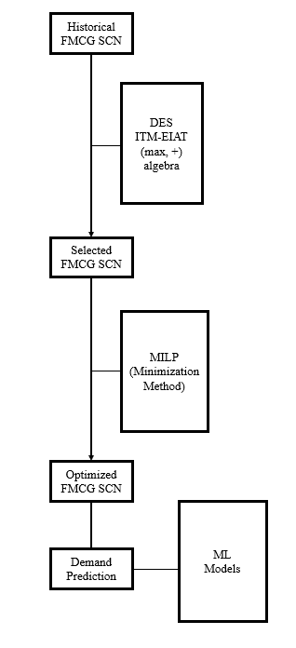
Fig. 3.1: Research Method follow-up

The Discrete Event System method procedure is shown in figure:
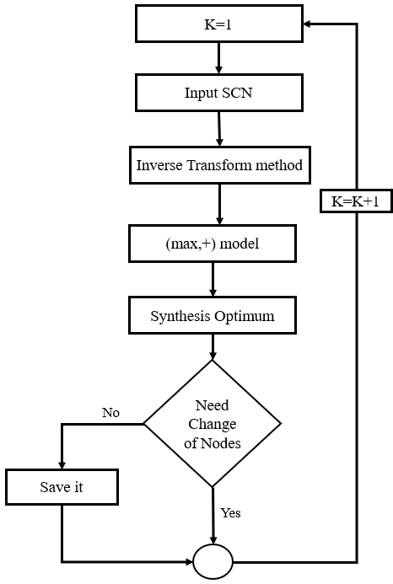
Fig.3.2: DES Method
The Mixed Integer Linear Programming method procedure is shown in figure:
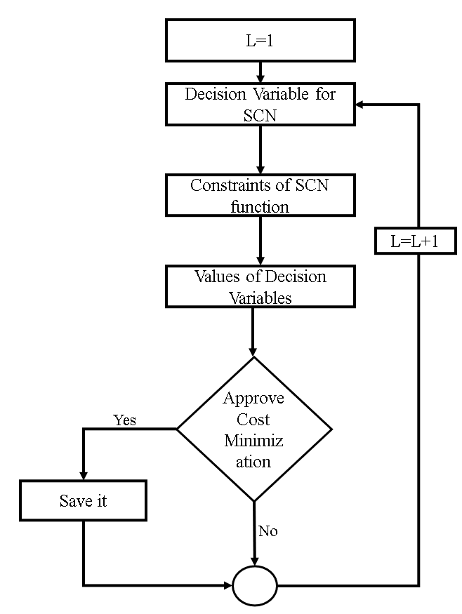
Fig.3.3: MILP Method

Results and Discussion

4.1 Initialization of Python Code
Python terminates a function which executes all other functions in a controlled manner not to have any discontinuity in analyzing dataset holding in multiple excel files.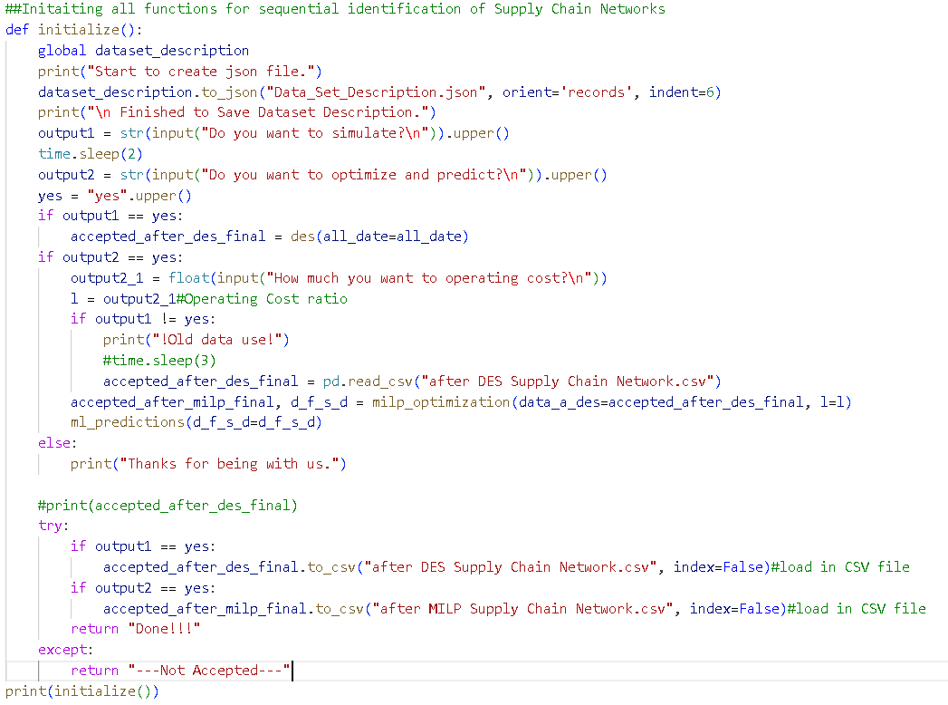
Fig.4.1: Program file Initialization

4.2 DataSet Description
From the Fast-Moving Consumer Goods dataset describing information about production. The programing in Python for extracting a json file for describing the data.
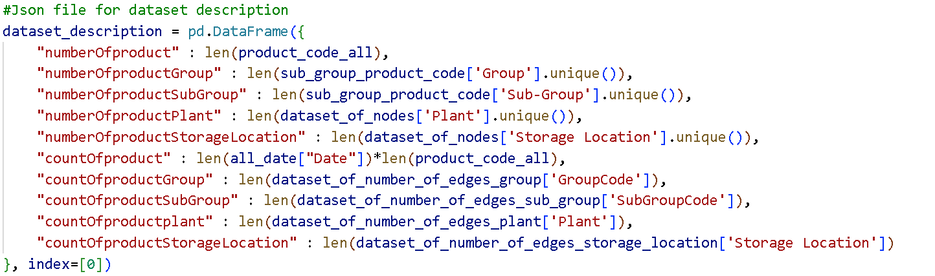
Fig. 4.2 Python programming arranging dataset description using pandas module
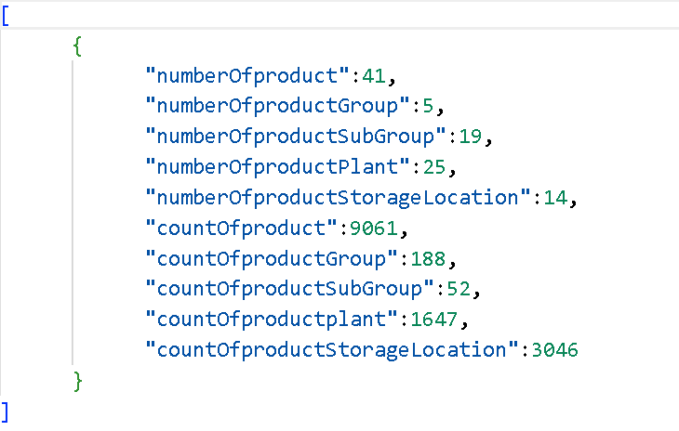
Fig 4.2.2 Python programming arranging dataset description in json file

After data extracting in all parameters, there creates an individual network of production process.
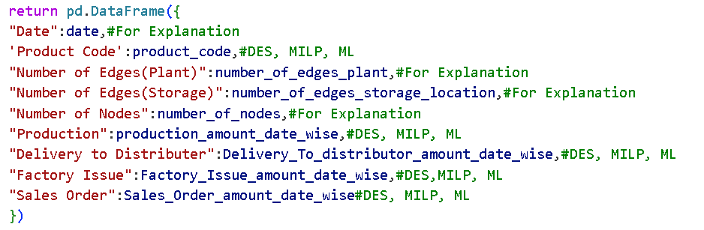
Fig. 4.2 Python programming for Network Data Organization.
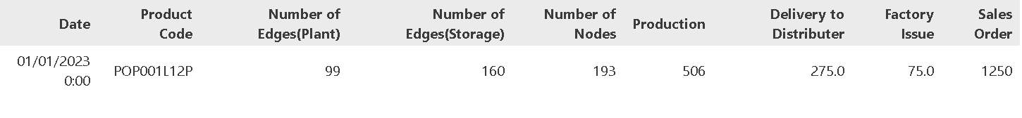
Fig. 4.3 Presenting a network Data Frame Extraction by Pandas module from multiple files.

4.3 Discrete Event Simulation Network Selection
In Discrete Event Simulation, any kind of zero unit of sales order and production amount do not accept the network. There have also sales order and production unit required for consumer demand evaluated to select random variable for Inverse Transform Method for Exponential Inter-arrival Times.
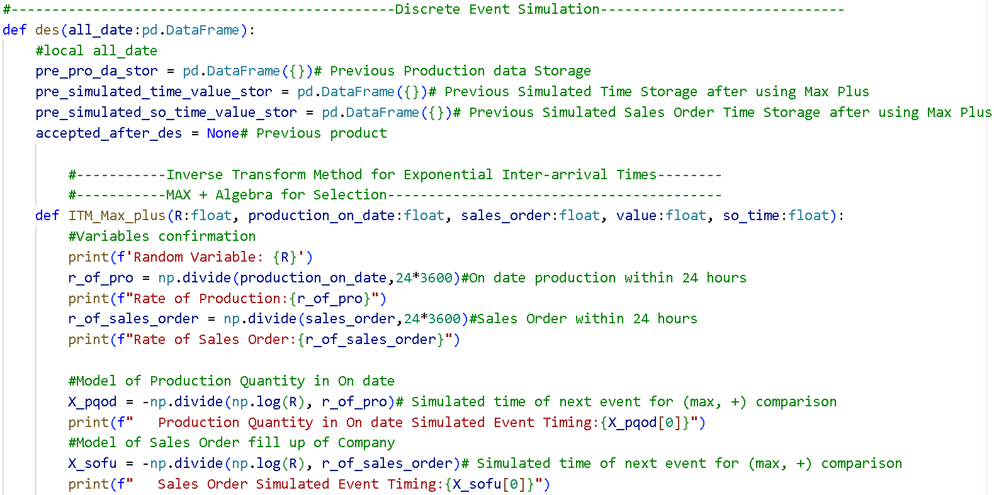
Fig. 4.4. Inverse Transform Method for Exponential Inter-arrival Times of Discrete Event Simulation by Pandas and Numpy module
The (max, +) algebra identifies the networks which could be selected. The selection executes through simulated time which recalls the previous time value.
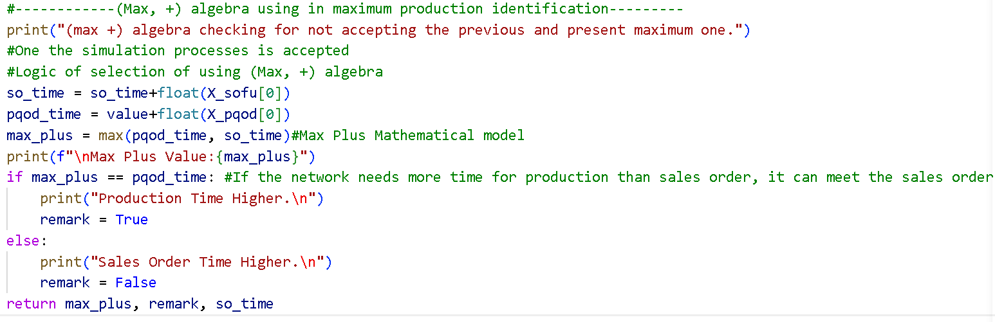
Fig. 4.5. The Dioid (Max, +) of Discrete Event Simulation by Pandas and Numpy module
The all data for simulation of selected networks by discrete event simulation which needs random variables, simulated time, previous spending time, maximize the consumption time for operation and merged with the last selected one.
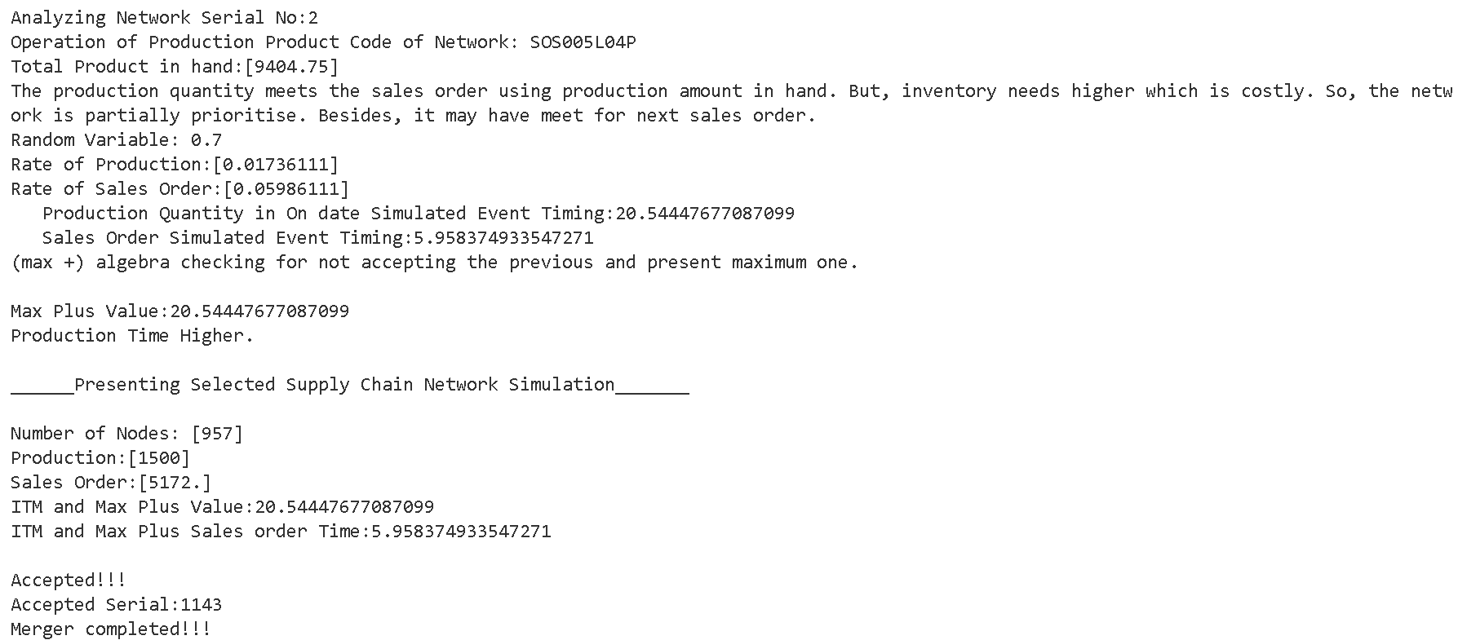
Fig. 4.6. The selected network with the presenting data with messages.
Most of the networks are not selected for their mathematical conditional issues.
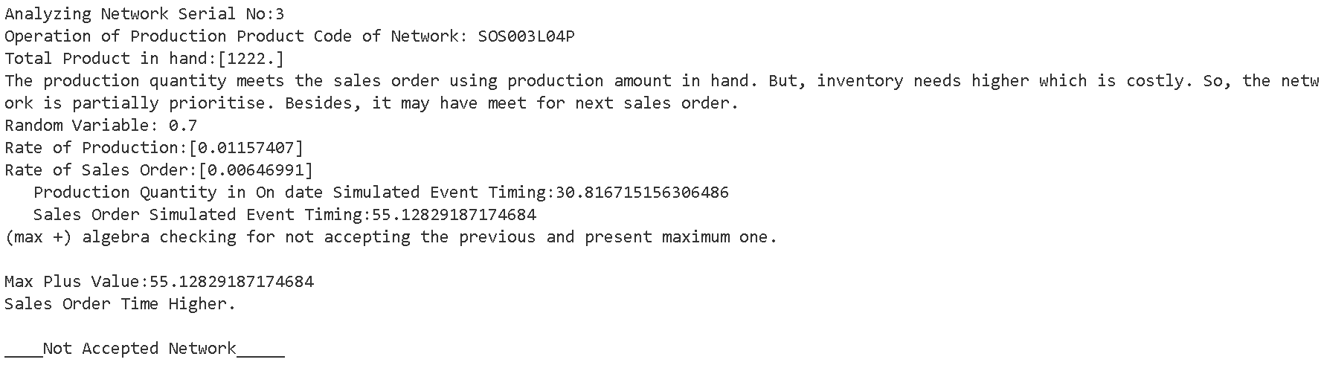
Fig. 4.7. The not selected network with the presenting data with messages
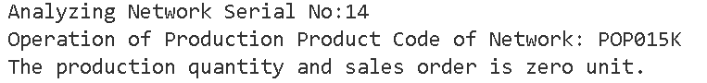
Fig. 4.8. The not selected network for zero unit
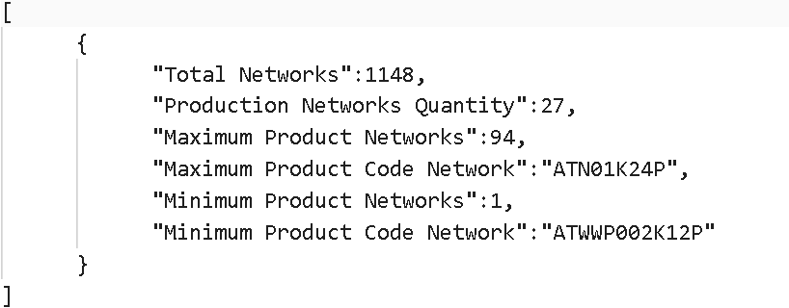
Fig. 4.9. Selected networks with maximum and minimum amount of networks

4.4 Mixed Integer Linear Programing Network Selection
The business strategies for profit counting by selecting delivery cost 25%, factory issue cost 10% and production cost 65%, eventually most of the 65% of operational cost optimize model.
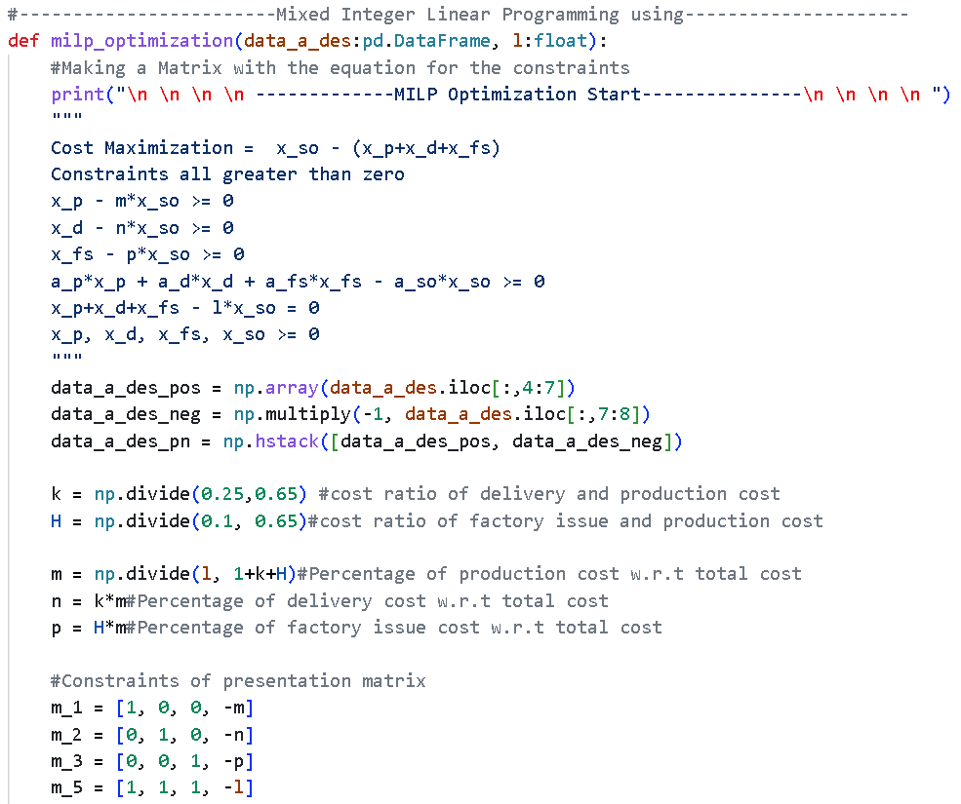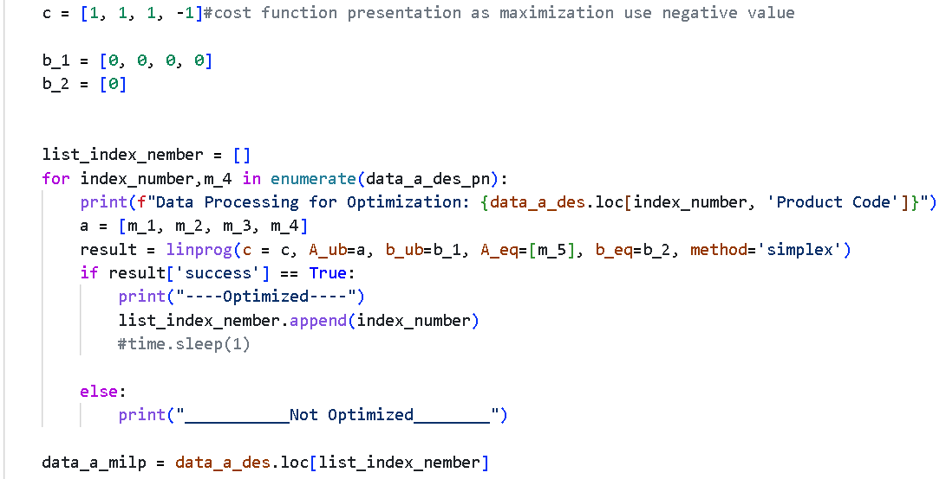
Fig. 4.10. Mixed Integer Linear Programming using Numpy and Scipy module
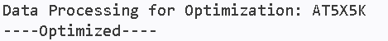
Fig. 4.11. The selected network by Mixed Integer Linear Programming with the presenting data with messages.
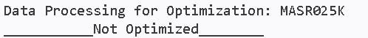
Fig. 4.12. The not selected network by Mixed Integer Linear Programming with the presenting data with messages
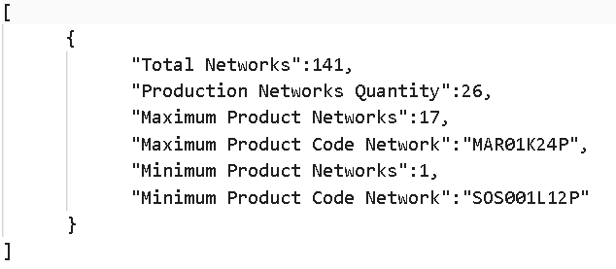
Fig. 4.13. Selected networks by Mixed Integer Linear Programming with maximum and minimum amount of networks.

4.5 Machine Learning model analysis
The selected Gaussian Mixture Model fitted data has its own covariance matrix as named as full. Besides, the initialization of weights, means and precisions responsibilities for model is used as randomly selected from data. Moreover, the cluster number is selected 15 after analyzing the maximum selected network product code by using mixed integer linear programming. For cross validation of model, it is required GirdsearchCV for selection actual Gaussian Mixture method with calculating Bayesian information criterion for mean scoring.
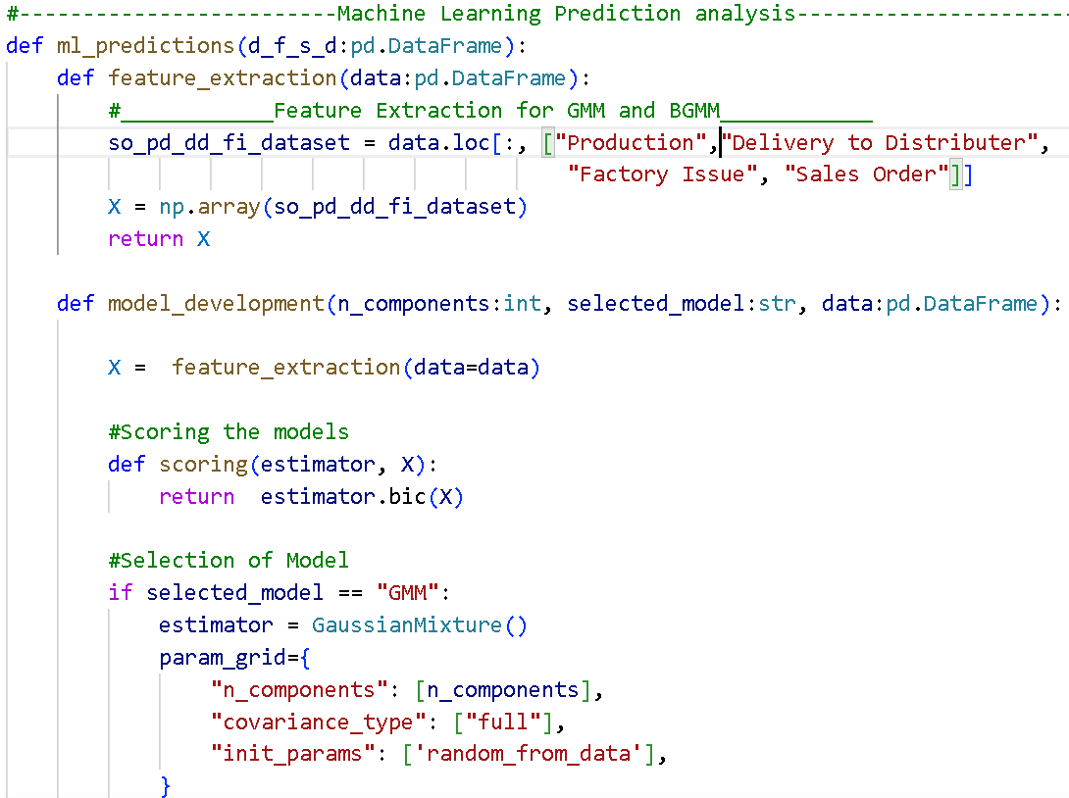
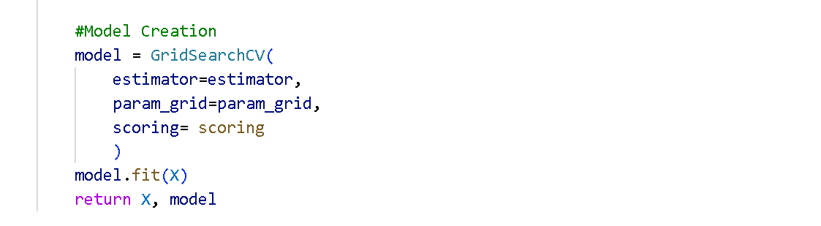
Fig. 4.14. Gaussian Mixture Model selection and creation
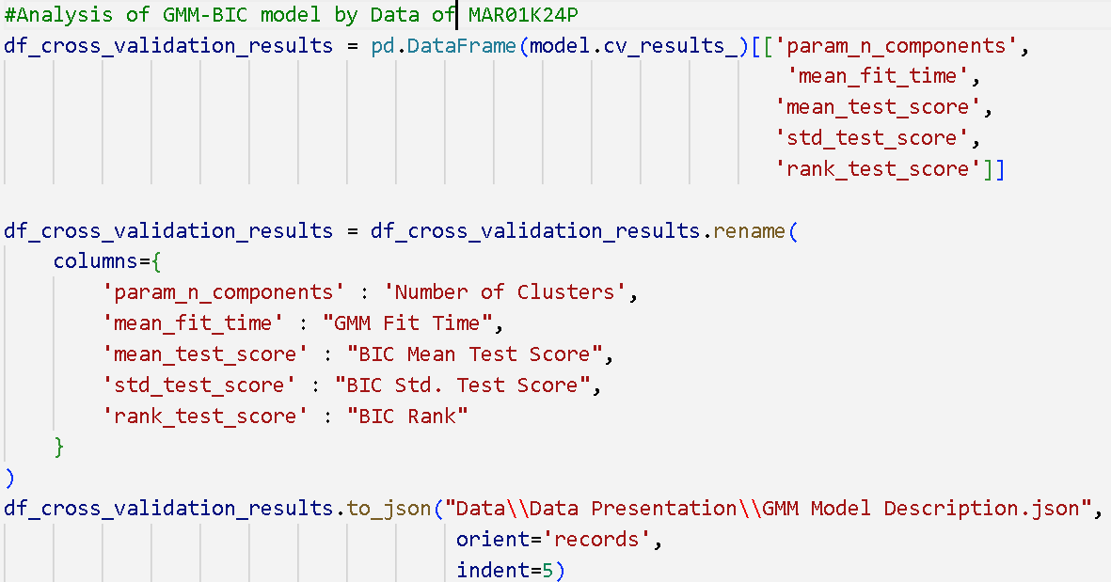
Fig. 4.15. Model validation code of maximum optimized Network fitted data
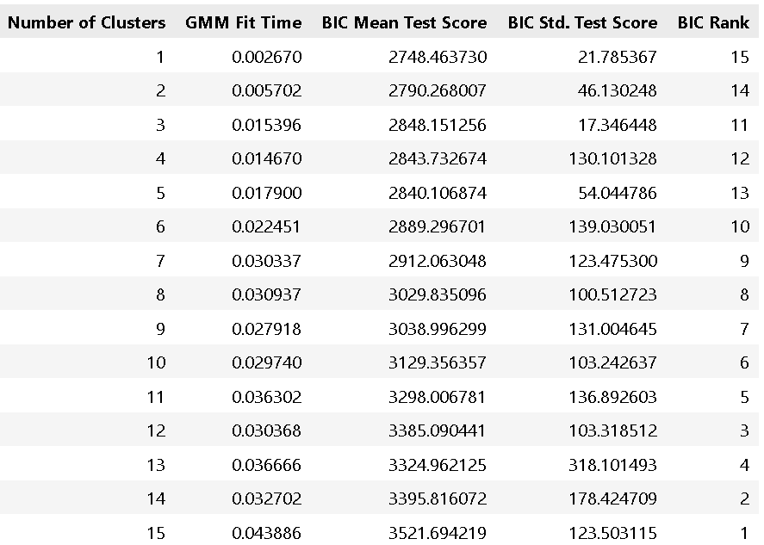
Fig. 4.16. Model validation information of maximum optimized Network fitted Pandas Data frame

4.6 Prediction of most clustered data
The maximum optimized network represents ‘MAR01K24P’ product code. It is functionated a Gaussian Mixture model to predict some cluster, required for future condition analysis.
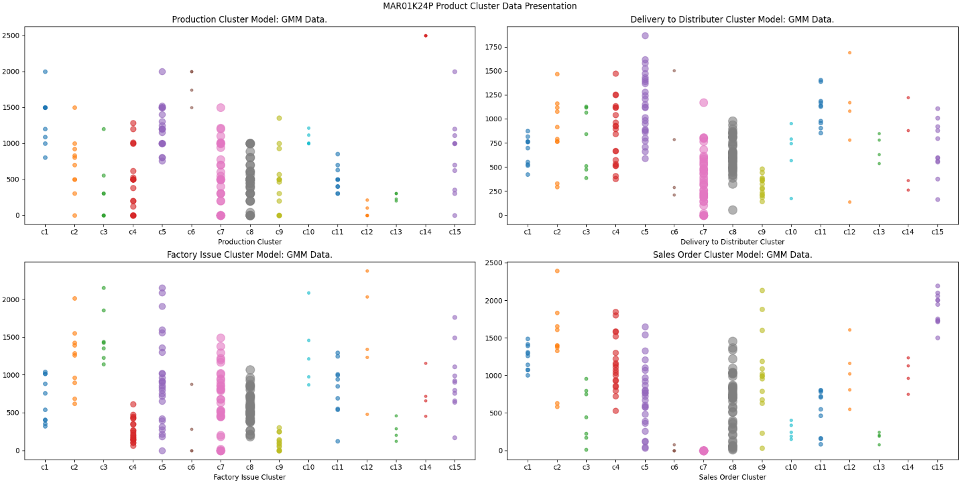
Fig. 4.17. Cluster data of ‘MAR01K24P’ product code network future analysis
From cluster graph of model, c7 and c8 no cluster for all parameters identify mostly. But, c4, c5, c9 are partially identified. According to c7 cluster, sales order may not present, but the three other parameters may present. It recalls that number of sales orders may bring negative profit in fast moving consumers goods though it is mostly optimized.

5.1 Supply Chain network discussion
Supply chain has many entities but production plays a great role to execute a successful profitable process. Production of Fast-moving consumer goods follows a multivariate and complex chain to become feasible for sustainability. As inventory, processing plant and product identification contemporize the supply chain, multiple commodities may ascertain from each entity. As a result, all products technically depend on each other.
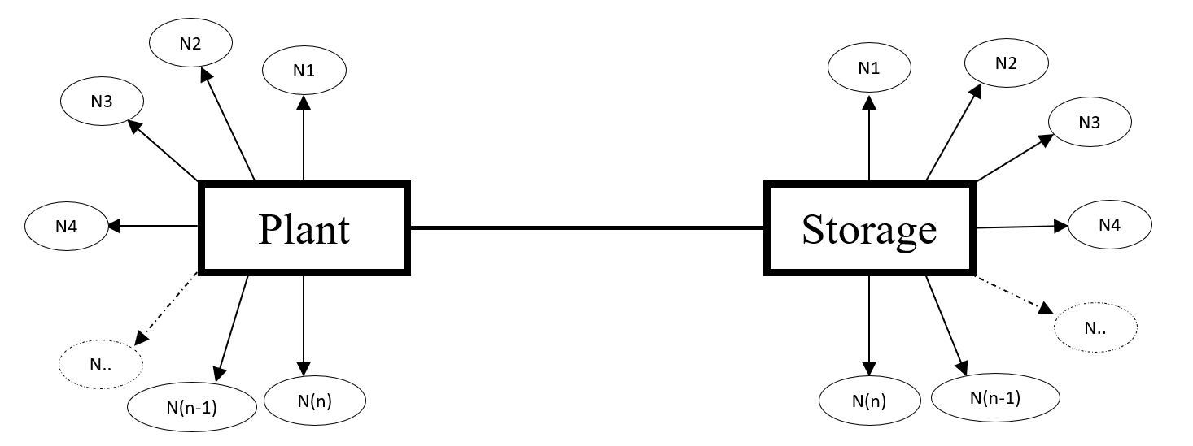
Fig. 5.1. Production commodities handling networks
Here, (N1, N2, N3, ………. N(n)) identifies as nodes and each N recalls ae product identification code. From above, multiple products that could remain in single plant and storage. But it becomes obvious that the feasibility and profitability pertain to lower costs and processes.

5.2 Discrete Event Simulation selected Networks
The dataset contains 42 product networks with 221 days temporal data. From this dataset, it could simulate around 1148 numbers of networks having non-zero value and some supply chain criteria. Besides, some conditions places on selecting networks according to supply chain operation possibilities. The numbers of network selection may represent in bar chart presenting below. The chart assists to identify the patterns of networks to configure the proceeded path. The display classifies the maximum count numbers exceeding eighty events in given timeline. The minimum numbers specialize to utilize rarely.
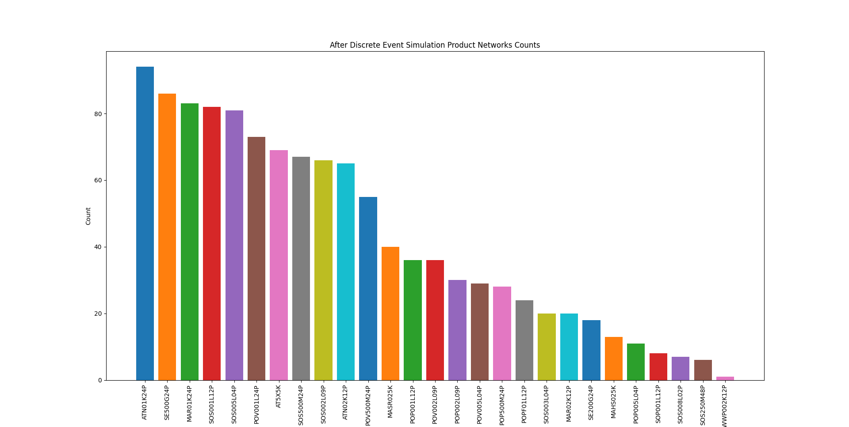
Fig. 5.2. Representation of networks numbers selecting by Discrete Event Simulation

5.3 Mixed Integer Linear Programming Networks
Discrete event simulation sorts out 1149 numbers of product networks by executing supply chain strategy, business condition and mathematical operations. Then, mixed integer linear programming employs to assessment of the simulated network to optimize them. The optimization process creates a differentiation of those networks pertaining to presenting on bar chart to identify the maximum and minimum numbers along with the transition of numbers in supply chain networks. The bar chart also ascertains to clarify the most profitable and feasible supply chain networks. In comparison with the discrete event simulation, most of the networks fails to optimize in mixed integer linear programming cost function distribution. The maximum value does not match with each other as seen in the bar charts.
As a result, optimum value of all costs indicates to re-route the networks or select those networks which terminate feasible outcomes in sense of highly profit margin to lessen the costs. This discussion may clarify that MAR01K24P product represents more better than ATN01K24P product. However, cost optimization fabricates actively eliminating the inefficient and under-utilized networks to direct on economical channel selection.
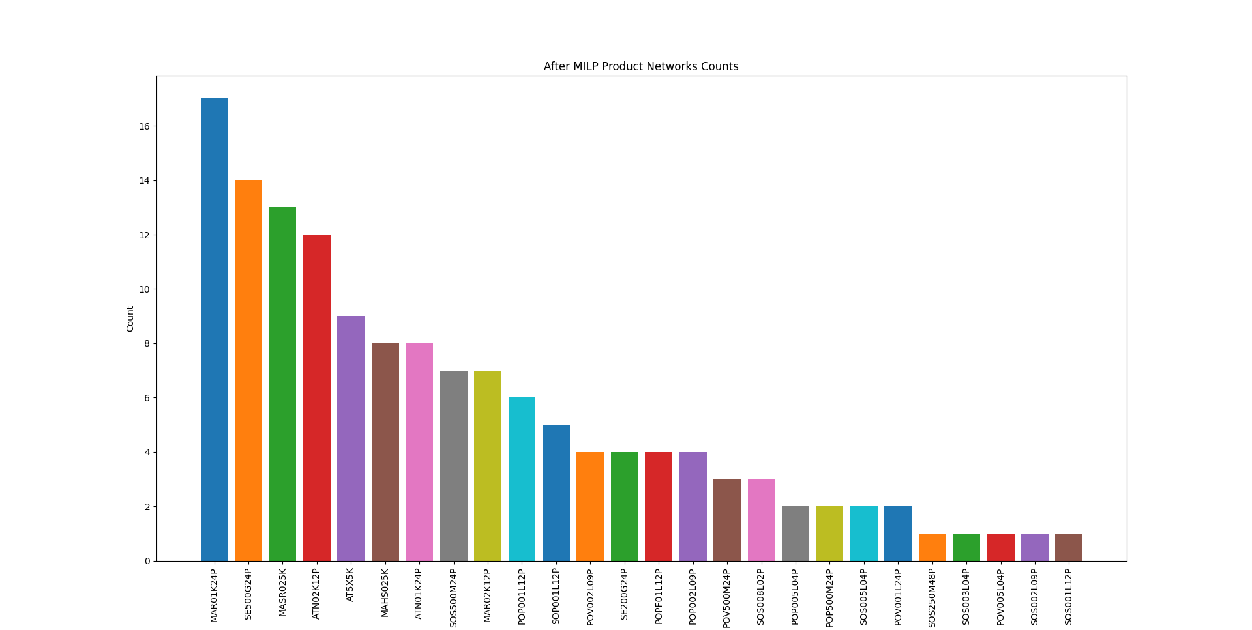
Fig. 5.3. Representation of networks numbers optimizing by Mixed Integer Linear Programming

5.5 Gaussian Mixture Method model Analysis
Optimized networks entail to illustrate the conditions by assessing machine learning to forecast.
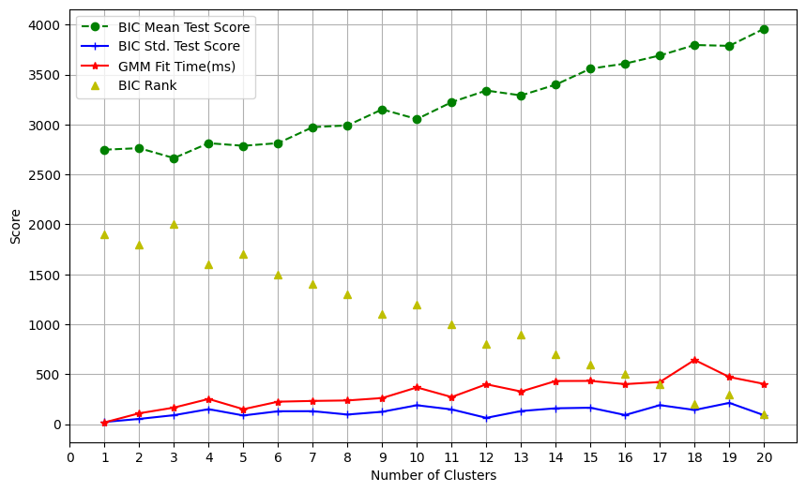
Fig. 5.4. Gaussian Mixture Model Analysis trained by MAR01K24P product dataset
Gaussian mixture method functionates as clustering data to identify more profitable conditions analyzing through probabilistic representation scoring in Bayesian Information criteria. The model has test scores which determine the best cluster number for the dataset needed. For that, cluster number 15 expect to selection as above model description dataset made to clarify. The rank displays also nearer to 1 for the selection cluster. Besides, the fit time becomes settle down for the cluster number 15 with nearer others. Finally, Gaussian Mixture method develops a 15 components-based clustering analysis to predict which numbers of values could be sustain the profit and feasibility.

5.6 Gaussian Mixture Method Prediction Analysis
The temporal dataset of MAR01K24P product code represents the unit of production, delivery to distributer, factory issue and sales order. The scatter chart presents daily units of parameters, extracting from supply chain process. Around 221 days of temporal data exist to evaluate the networking system of the product. It manipulates the prediction of upcoming situation to executing the clusters. From chart, the data become more fluctuation of time. But production and sales order pervade to zero value more. In contrast, the non-zero value imbue to spurn from the selection process. However, the product code sticks out stance maximum times of preference and associate execution for supply chain process.
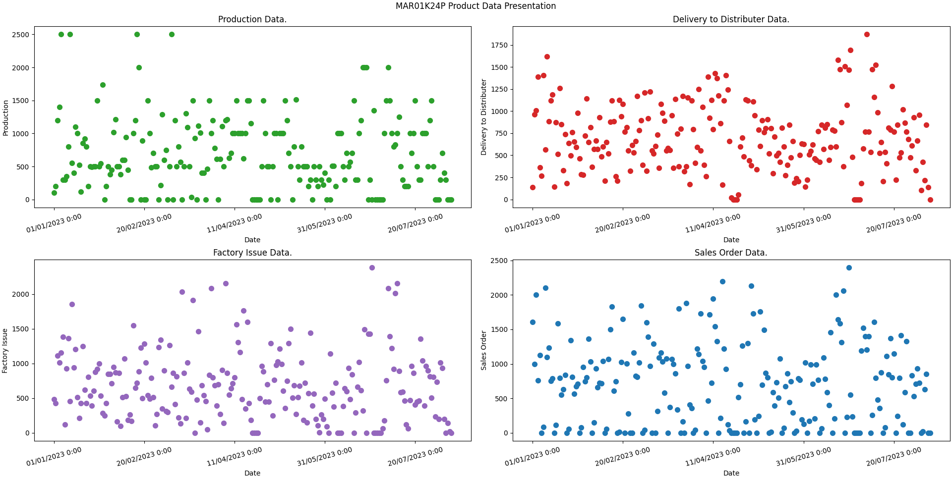
Fig. 5.5. Temporal Data presentation of MAR01K24P product code
Gaussian Mixture model manipulates the dataset as applying mathematical equations to identify utilizable cluster for assisting decision maker. It seeks to ask for appropriate numbers of cluster by analyzing the score of machine learning back test finalizing fifteen as cluster number. The model evolves with fifteen different clusters and creates a statistical boundary for each.

Fig. 5.6. Cluster dataset after machine learning model prediction
The graph shows 4 clusters mostly dense enough as the probabilistic maximum argument presenting on those. The argument constructs most intensely cluster number eight as execution in real life according to this statistical representation. But sales order and production plot illustrate the range of both parameters not to be nearer. The other two parameters technically cause to consummate the sales order smoothly. Moreover, the second one fails to accomplish sales order detection as zero value picking out applying probabilistic argument. The all other may not to select for less number model prediction.

Conclusions
The research will be demonstrated that data driven decision can be more effective and applicable for this modern world. Supply Chain Networks should be cost effective and eco-friendly operation to maintain Sustainable Development. Exploring mathematical models of Discrete Event System, Mixed Integer Linear Programming, and Machine Learning models can create an appropriate procedure for analyzing the Supply Chain Networks. Developing more precise process for taking decisions is a noteworthy procedure to analyze Supply Chain Strategies.
The research demonstrated that data driven decision taking MAR01K24P product network. Cost effective operation selects node connection 309, edges connection 51 plants and 148 storage locations. The c8 number cluster length is 49 which is maximum. Finally, the network sales order range 1000 units and maximum 1000 units. As a result, MAR01K24P is most profitable business.
The main finding of this research observes to identify the product code supply chain network executing in physical world. The Discrete event simulation applies simulated time mathematics and conditions of supply chain criteria to determine primary product code. Then, optimization of network profit recognizes through mixed integer linear programming to incompetent more networks for finding out the sustainable one.
In future, the research may contain to develop more adding other complex and efficient mathematical formula for Discrete Event simulation for simulating time and enlarge to significant selection process of production conditions. Besides, machine learning evolves more fast, complex and efficiently. As a result, the prediction process would pertain to more mathematical and statistical model used and determine precise result of clusters.
To sum up, this research directs to manage the strategical decision maker to evaluate production quantity, inventory and transportation processes and their cost optimization. However, it necessitates to work more expanding and upgrading simulation identification to prediction of networks.

References
[1] S. Joshi, ‘A review on sustainable supply chain network design: Dimensions, paradigms, concepts, framework and future directions’, Jan. 01, 2022, KeAi Communications Co. doi: 10.1016/j.susoc.2022.01.001.
[2] P. Dey, H. Mural, A. Dash, Md. F. Kabir, T. J. Nuva, and M. J. Islam Seyam, ‘Evaluation of Strategies for Eradicating Supply Chain Disruption in Steel and Rolling Industries in Bangladesh by MCDM Approaches’, IEOM Society International, Apr. 2025. doi: 10.46254/ba07.20240058.
[3] I. Mallidis, S. Despoudi, R. Dekker, E. Iakovou, and D. Vlachos, ‘The impact of sulphur limit fuel regulations on maritime supply chain network design’, Ann. Oper. Res., vol. 294, no. 1–2, pp. 677–695, Nov. 2020, doi: 10.1007/s10479-018-2999-4.
[4] R. Golini, F. Caniato, and M. Kalchschmidt, ‘Supply chain integration within global manufacturing networks: a contingency flow-based view’, Journal of Manufacturing Technology Management, vol. 28, no. 3, pp. 334–352, Apr. 2017, doi: 10.1108/JMTM-11-2015-0100.
[5] B. Meredig, ‘Industrial materials informatics: Analyzing large-scale data to solve applied problems in R&D, manufacturing, and supply chain’, Curr. Opin. Solid State Mater. Sci., vol. 21, no. 3, pp. 159–166, Jun. 2017, doi: 10.1016/J.COSSMS.2017.01.003.
[6] R. Golini, F. Caniato, and M. Kalchschmidt, ‘Supply chain integration within global manufacturing networks: a contingency flow-based view’, Journal of Manufacturing Technology Management, vol. 28, no. 3, pp. 334–352, Apr. 2017, doi: 10.1108/JMTM-11-2015-0100.
[7] H. Inoue and Y. Todo, ‘Firm-level propagation of shocks through supply-chain networks’, Nat. Sustain., vol. 2, no. 9, pp. 841–847, Sep. 2019, doi: 10.1038/s41893-019-0351-x.
[8] A. Roshani, P. Walker-Davies, and G. Parry, ‘Designing resilient supply chain networks: a systematic literature review of mitigation strategies’, Ann. Oper. Res., vol. 341, no. 2–3, pp. 1267–1332, Oct. 2024, doi: 10.1007/s10479-024-06228-6.
[9] Z. Alkalha, B. Dehe, and I. Reid, ‘How absorptive capacity mediates supply chain effectiveness: a quality integration approach to boosting operational performance’, Operations Management Research, Sep. 2025, doi: 10.1007/s12063-025-00559-8.
[10] M. H. Akyüz, R. Dekker, and S. Sharif Azadeh, ‘Partial and complete replanning of an intermodal logistic system under disruptions’, Transp. Res. E Logist. Transp. Rev., vol. 169, Jan. 2023, doi: 10.1016/j.tre.2022.102968.
[11] Y. Idel Mahjoub, E. houcine Chakir El-Alaoui, and A. Nait-Sidi-Moh, ‘Logistic network modeling and optimization: An approach based on (max,+) algebra and coloured Petri nets’, Comput. Ind. Eng., vol. 158, Aug. 2021, doi: 10.1016/j.cie.2021.107341.
[12] N. Chiadamrong and V. Piyathanavong, ‘Optimal design of supply chain network under uncertainty environment using hybrid analytical and simulation modeling approach’, Journal of Industrial Engineering International, vol. 13, no. 4, pp. 465–478, Dec. 2017, doi: 10.1007/s40092-017-0201-2.
[13] A. Abouelrous, R. Dekker, L. Bliek, and Y. Zhang, ‘Real-time policy for yard allocation of transshipment containers in a terminal’, Transportation Research Part B: Methodological, vol. 192, Feb. 2025, doi: 10.1016/j.trb.2024.103138.
[14] J. J. Vicente, ‘Optimizing Supply Chain Inventory: A Mixed Integer Linear Programming Approach’, Systems, vol. 13, no. 1, Jan. 2025, doi: 10.3390/systems13010033.
[15] A. S. Eruguz, O. Karabağ, E. Tetteroo, C. van Heijst, W. van den Heuvel, and R. Dekker, ‘Customer-to-customer returns logistics: Can it mitigate the negative impact of online returns?’, Omega (United Kingdom), vol. 128, Oct. 2024, doi: 10.1016/j.omega.2024.103127.
[16] R. Toorajipour, V. Sohrabpour, A. Nazarpour, P. Oghazi, and M. Fischl, ‘Artificial intelligence in supply chain management: A systematic literature review’, J. Bus. Res., vol. 122, pp. 502–517, Jan. 2021, doi: 10.1016/J.JBUSRES.2020.09.009.
[17] M. Akbari and T. N. A. Do, ‘A systematic review of machine learning in logistics and supply chain management: current trends and future directions’, Benchmarking: An International Journal, vol. 28, no. 10, pp. 2977–3005, Nov. 2021, doi: 10.1108/BIJ-10-2020-0514.
[18] A. M. Khedr and S. R. S, ‘Enhancing supply chain management with deep learning and machine learning techniques: A review’, Journal of Open Innovation: Technology, Market, and Complexity, vol. 10, no. 4, p. 100379, Dec. 2024, doi: 10.1016/J.JOITMC.2024.100379.
[19] K. R. Ahmed, M. E. Ansari, M. N. Ahsan, A. Rohan, M. B. Uddin, and M. A. H. Rivin, ‘Deep learning framework for interpretable supply chain forecasting using SOM ANN and SHAP’, Sci. Rep., vol. 15, no. 1, pp. 1–28, Dec. 2025, doi: 10.1038/S41598-025-11510-Z;SUBJMETA=1042,117,531,639,705;KWRD=COMPUTATIONAL+SCIENCE,COMPUTER+SCIENCE,MATHEMATICS+AND+COMPUTING,STATISTICS.
[20] A. T. Wasi, M. S. Islam, and A. R. Akib, ‘SupplyGraph: A Benchmark Dataset for Supply Chain Planning using Graph Neural Networks’, Jan. 2025, [Online]. Available: http://arxiv.org/abs/2401.15299
[21] Y. Ma and Z. Li, ‘Clustering ensemble method integrating Gaussian mixture model and three-way decision (GMM-3WD-CE)’, Sci. Rep., vol. 16, no. 1, Dec. 2026, doi: 10.1038/s41598-026-47453-2.

